Exercise 2

1.Write the Select statement to extract the ids of employees who are more than 30 years of age.
SELECT * FROM employee_data WHERE age > 30;
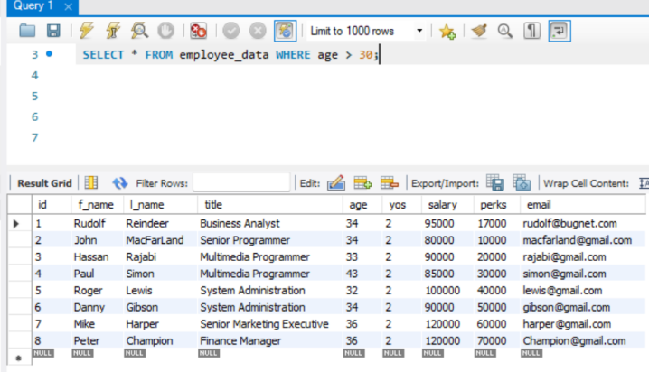
2. Write the select statement to extact the first and last names of all web designers.
SELECT f_name, l_name FROM employee_data WHERE title like "web designer" or SELECT f_name, l_name FROM employee_data WHERE title = "Web Designer"

3. what will the following Select statement display:
Will return all rows that has a salary less than or equal to 100 grand
4. How will you display the salaries and perks for employees who have more than $16000 as perks?
SELECT salary, perks from employee_data WHERE perks > 16000;

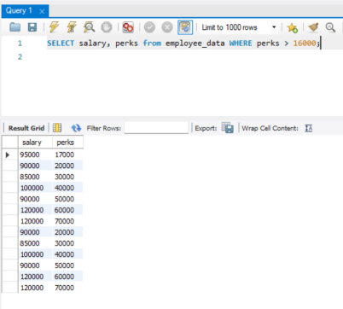
5. List all employee names (last name followed by first name) who hold the title of Marketing executive.
SELECT l_name, f_name FROM employee_data WHERE title like "marketing executive" or SELECT l_name, f_name FROM employee_data WHERE title = "Marketing Executive"

